NSPR GOVERNMENT DEGREE COLLEGE(W) HINDUPUR

DEPARTMENT OF TELUGU

**PERSONAL PROFILE:**

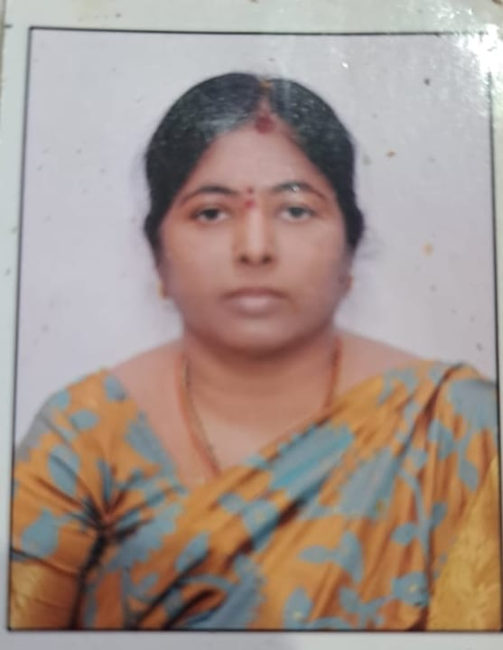

Dr. C.HEMAMMARUTHI,MA,M,LISC,Ph.D AP,SET

Lecturere In Telugu

Mobile :9441361554

Email:chittahema1554@gmail.com

University :Sri Krishna Devaraya University

Additional Qualification : Passed State Eligibility Test

: Conducted Government of

In Charge of Telugu department

Additional Responsibilities : In the present station

NSPR GOVT DEGREE COLLEGE (w)HINDUPUR

Mentor for the second year Becom (computer Application)

**Communtity Service Project Group**

One of the Member of Woment Empowerment Cell

**PARTICIPATION IN FACULTY DEVELOPMENT PROGRAMME**

1.Participated in 5 days faculty development programme organized byCCEAP,Vijayawada

Held from 17-8-2020 to 21-8-2020.

2.Participated in FIVE DAYS RESIDENTIAL TRAINING PROGRAMME FOR TEACHEER s

On Content delivery and assessment methods pertaining to skill courses for 1semester

Human Values and professional Ethics (HVPE) from 30.11.2022 to 4.12.2022 orgnized by

Commissionerate of Collegiate education AP Mangalagiri

3.Participated in three days Training Programme on Internsip and L.M.S held at Nodal Reource Center, Govt college (Autonomous),Anantapuram from05.01.2023 to 07.01.2023.

4.Participated in Online Refresher Course in Language &Linguistics organized by UNIVERSITY GRANTS COMMISSION HUMAN RESOURCE DEVELOPMENT CENTER OsmaniaUniversity,Hyderabad

Telangana from 24.1.2023 to 7.2.2023

5. Participated single day non Resudential Training of Trauberes (TOT) Programme for UNESCO-MGIEP Certificate Courses – SEEK& SEL Organised by commissionrate of Collegiate education :: A.P

Mangalagiri